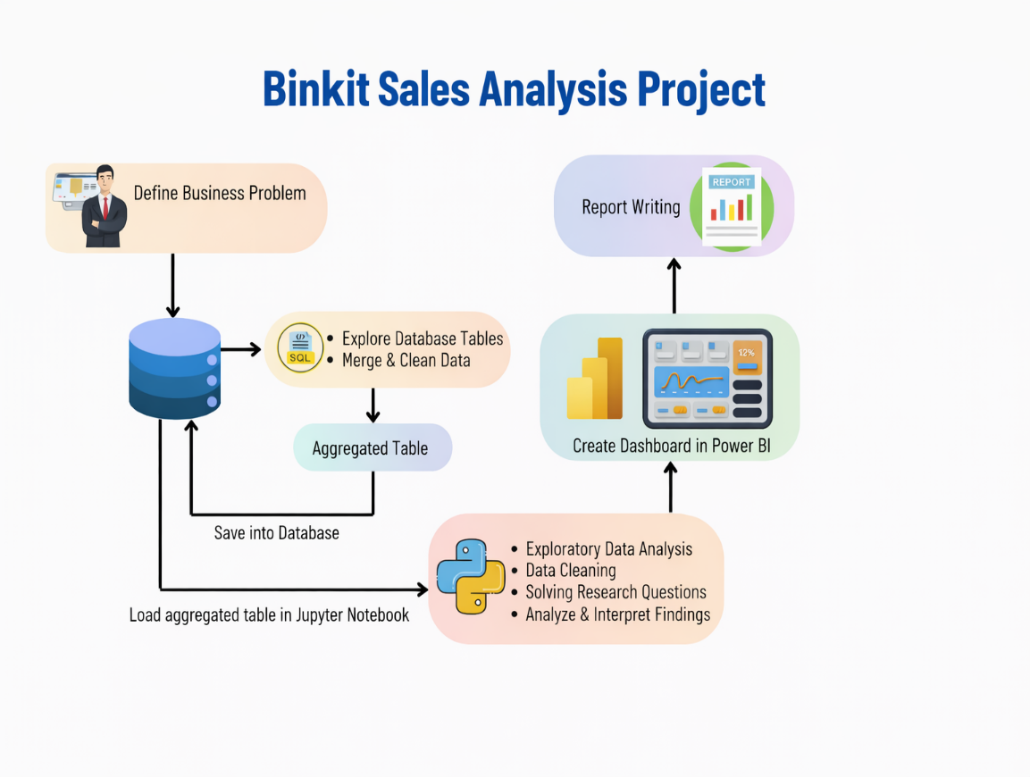

Business Problem
This report analyzes Blinkit sales data to understand sales trends, category performance, pricing impact, and delivery efficiency. The dataset contains 5000 orders across 11 categories. The analysis reveals that grocery staples contribute the highest revenue, while higher-priced products show lower margins. Recommendations focus on category optimization and delivery improvement.
Blinkit frequently runs promotional campaigns to increase order volume, customer acquisition, and category penetration. These campaigns include discount offers, festive sales, cashback deals, free delivery, and category-specific promotions.
- Identify Brands the perform best & those brands that perform low they need promotions and pricing adjustments
- Determine the top categories of products the contribute in most sales revenue
- Analysis the low and bulk stock & low stock on unit cost
- Investigate the profitability variance between high-performing and low-performing category
- Measure campaigns effectiveness on sales or order
- Identifying top performing campaigns
- Identifying campaigns that give high ROAS on spend

Summary Statistics
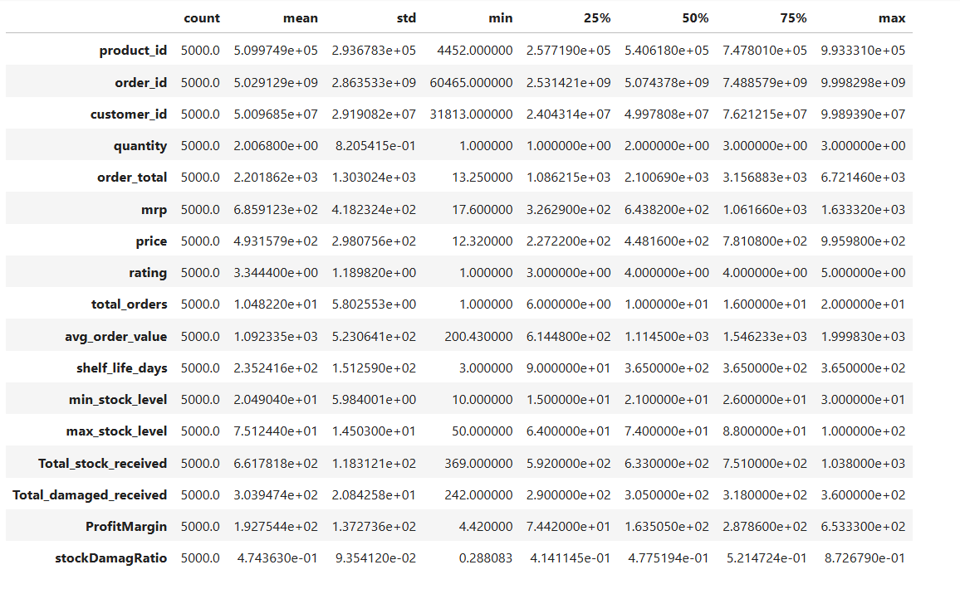

Numerical Data view
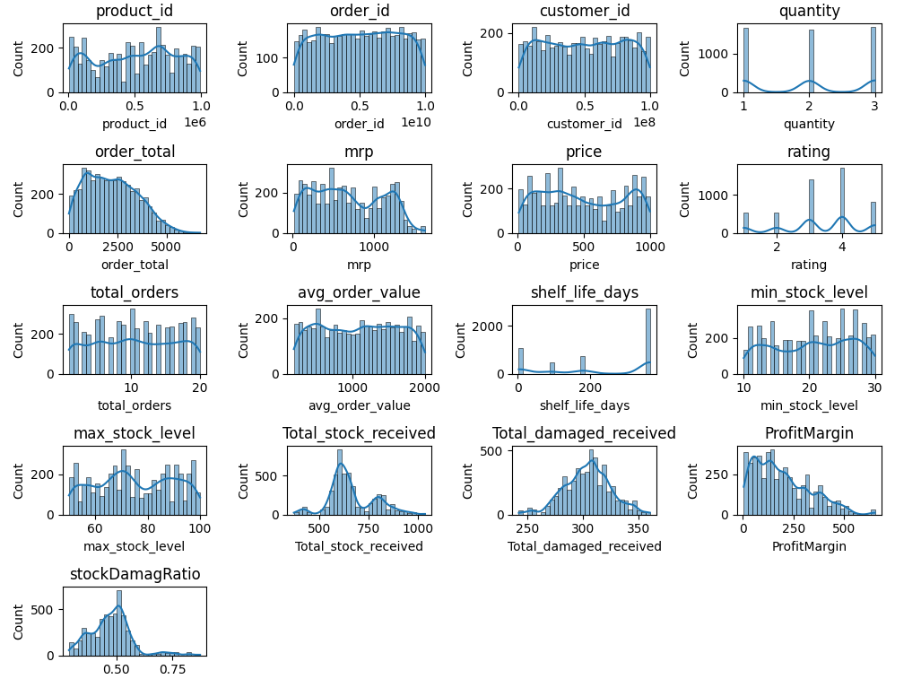
Pricing & Revenue:
- Price distribution spans ₹50 to ₹1000 with higher frequency in the ₹200 to ₹700 range indicating strong demand for mid-priced
- Order Total is right-skewed, with most orders below ₹3,000,
Inventory & stock:
- Minimum Stock Levels are mostly between 10–30 units, while Maximum Stock Levels lie between 50–100 units,
Damage & Quality Control:
- Total Damaged Stock Received peaks around 280–320 units
- Stock Damage Ratio is concentrated around 0.45–0.55, indicating that nearly half of damaged stock impacts usable inventory,
Profitability
Profit Margin distribution is right-skewed, with most products earning ₹50–₹300 margin, while a few high-margin products significantly boost profitability
Customer Rating are mostly 3 to 5.
Numeric summary
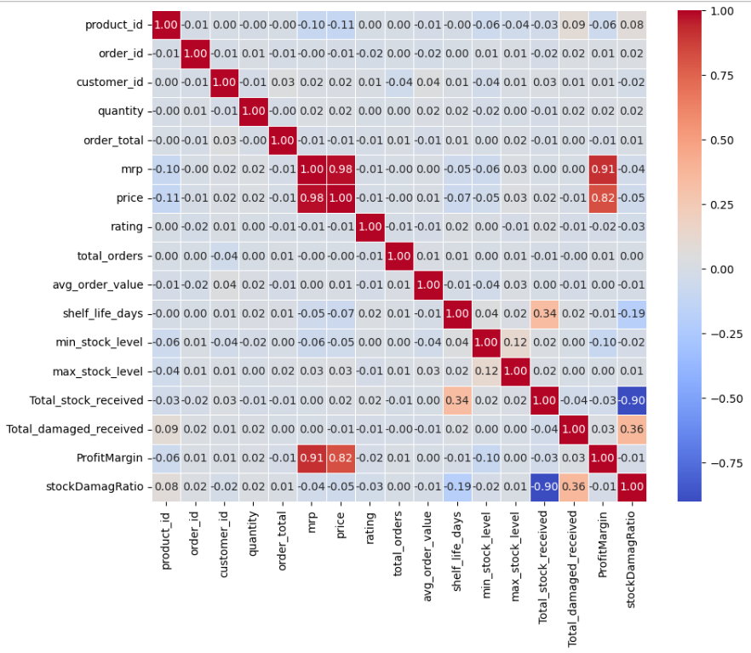
Pricing & profitability
- MRP and Price show an extremely strong positive correlation (0.98), confirming consistent pricing control and minimal deviation from listed prices
- Profit Margin has a strong positive correlation with MRP (0.91) and Price (0.82), indicating that higher-priced products contribute significantly more to overall profit.
Inventory & stock
- Total Stock Received vs Stock Damage Ratio shows a strong negative correlation (-0.90),it mean larger stock inflows reduce relative damage impact
- Total Damaged Stock Received has a moderate positive correlation with Stock Damage Ratio (0.36), highlighting that as damaged units increase, overall stock efficiency declines
- Shelf Life Days has a moderate positive correlation with Total Stock Received (0.34), suggesting higher stocking volumes for long shelf-life products.
Demand & order Behaviour
- Quantity, and Total Orders show very weak correlations with pricing variables, implying that customer purchase volume is relatively price-inelastic for daily essentials.
- Product Rating has negligible correlation with Price, Quantity, and Profit Margin, suggesting that customer satisfaction is influenced more by delivery speed, freshness, and service quality than pricing.
Rescarch Questions & Key findings
Q.1: Brand for promotional and price adjustment
Brand with Low sales But High margin v/s Brand with high sales but Low margin
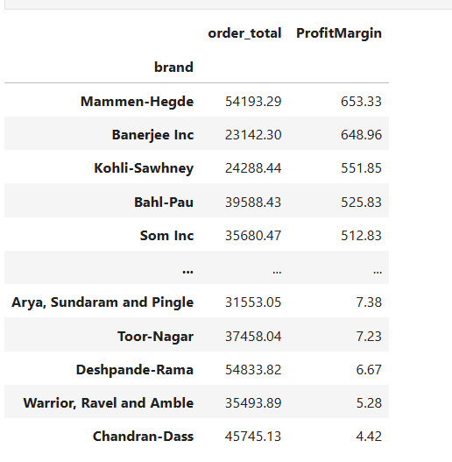
Approximate 110 Brand exhibit lower sales but higher profit margins, which could benefit from targeted marketing, promotions, or price optimizations to increase volume without compromising profitability
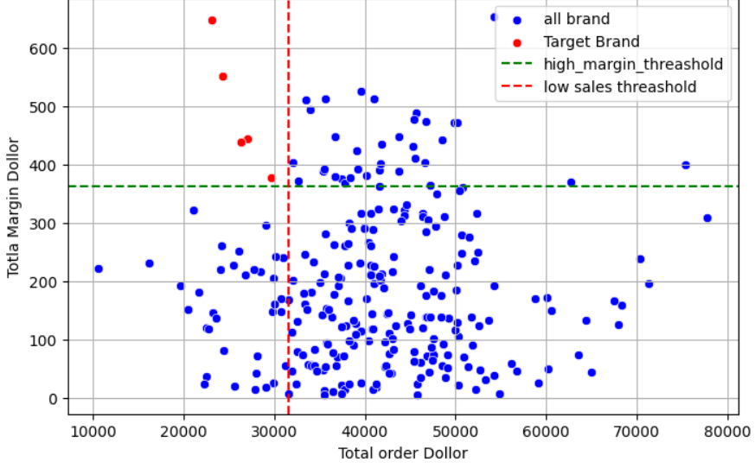
- There is few brands that total order contribution is <15% and profit Margin> 85%
- For increase sales we need price adjustment and promotion for increase sales and profit margin
Q.2 All category sales contribution
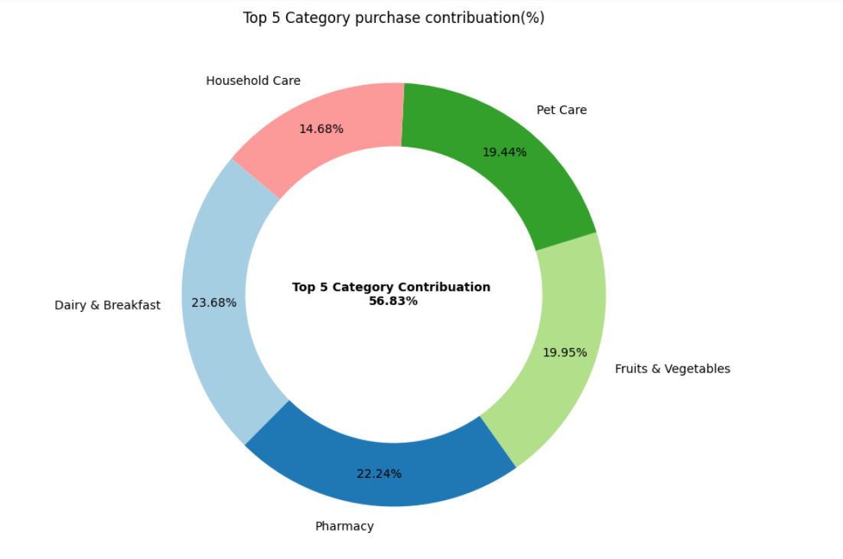
- Top 5 category contribute 56.83% in overall sales
- Dairy & Breakfast(23.68)% Pharmacy(22.24)%, Fruits & vegetables(19.95)%, pet care(19.44)% and Household Care(14.68)% are most demanding category

Q.3 Top Brands
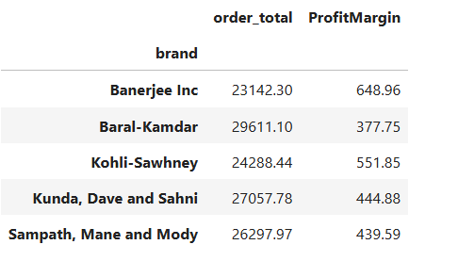
- That 5 Brans Contribute Most sales and Profit Margin (focus on this brands promotions for increase sales and profit margin

Q.4. Impact of Bulk purchasing on cost savings
- Large orders have the highest median unit price (~₹280–₹300), indicating that customers placing large orders tend to include higher-value or premium products
- Large orders contribute disproportionately to revenue, even at similar order counts.
- Medium orders have the lowest median unit price (~₹190–₹210), suggesting stronger presence of discounted or everyday essentials.
- Medium-size orders represent a price-sensitive segment, ideal for:
  - Combo offers
- Volume-based discounts
- Small orders align with Blinkit’s quick-commerce promise, driven by urgent needs rather than price optimization.
Large > Small > Medium

Marketing campaign Performance
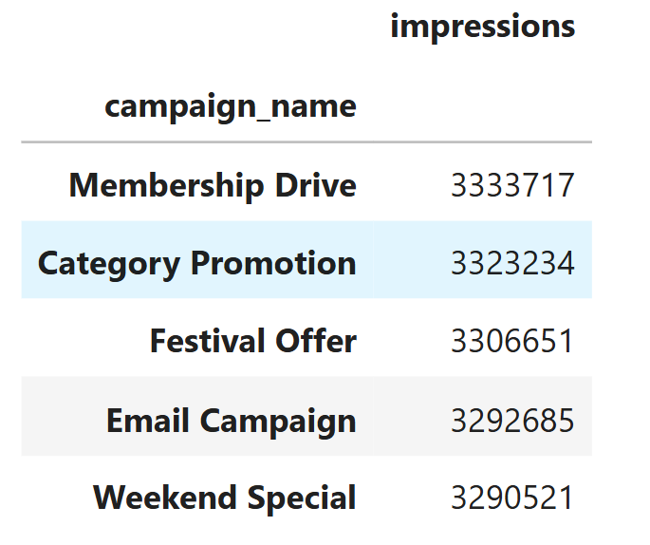
- Top 5 campaign that generate more high users reach
- We have to organize that types of campaign that interact more viewers
Channel
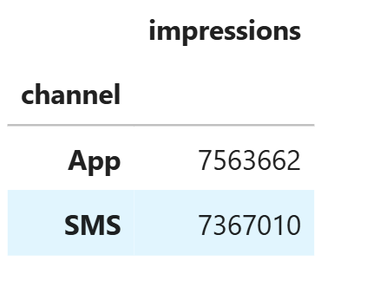
- App(7.56M) and SMS(7.37M) are perform well that interact more users
- Other channel is perform like social (7.28M) & Email(7.28M) good but less then App & SMS
Impressions / click / conversions & Revenue generated
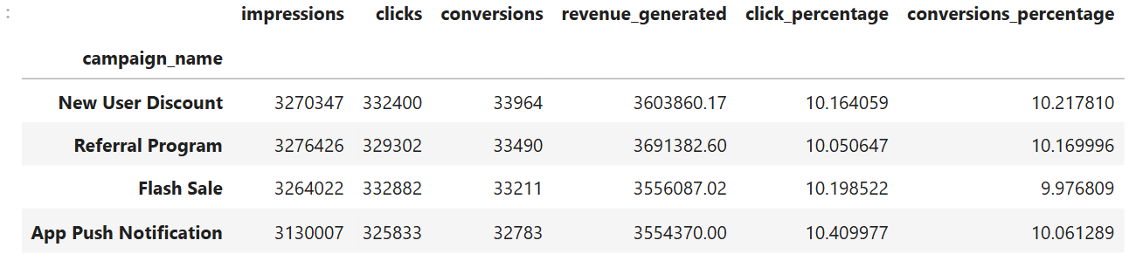
There is few campaign that total impression contribution is <15% and Revenue generation contribution > 85%
- All Top 5 campaigns generated almost similar impressions (3.1–3.3 million), indicating balanced exposure and uniform marketing reach.
- App Push Notification achieved the highest click-through rate (10.41%), showing strong user engagement through direct app-based communication.
- The Referral Program generated the highest revenue (₹3.69M), highlighting its effectiveness in driving high-value conversions through trust-based referrals.
- New User Discount recorded the highest conversion rate (10.22%), suggesting discounts are highly effective in converting first-time users.
- New User Discount recorded the highest conversion rate (10.22%), suggesting discounts are highly effective in converting first-time users

Tools & Technologies Used
- Python
Used for data cleaning, transformation, and analysis.
- Pandas & NumPy
Pandas was used for data manipulation and aggregation, while NumPy supported numerical computations.
- Matplotlib & Seaborn
Used for statistical data visualization such as bar charts, histograms, and trend analysis.
- SQLite3
Used as a lightweight relational database to store processed data and perform SQL queries.
- SQLAlchemy
Used to create database engines and enable seamless interaction between Python and SQLite.
- Power BI
Used for creating interactive dashboards and KPI visualizations.
- SQL
Used for querying structured data and generating aggregated insights

Recommendation

